

Contents

**3. Tasks** 2

**3.1. Literature Review** 2

**3.1.a. MPPT Algorithm 1 ()** 2

**3.1.b. MPPT Algorithm 2 ()** 2

**3.1.c. MPPT Algorithm 3 ()** 2

**3.2. Design of an improved MPPT Algorithm** 3

**3.2.a. Statement on the Design Chosen** 3

**3.2.b. Flow Chart of the Proposed MPPT Algorithm** 3

**3.3. Implementation and Testing of the Proposed MPPT Algorithm** 3

**3.3.a. Results** 3

# **3. Tasks**

## **3.1. Literature Review**

### **3.1.a. MPPT Algorithm 1 (Improved Perturb & Observe)[1]**

**What particular issue of MPPT has this paper addressed?**

The perturb and observe method is one of the most common MPP Tracking in the real world. By perturbing the circuit and observing its behaviour and the output power, the duty cycle is changed in order to reach its maximum power point. Several papers have been studied and all reached the same goal: improving the p&o method. The major issue of the p&o method is the inability to adapt to drastic changes in the environment, and losing focus and sight of the maximum power point before stabilising again.

**What is the algorithm of the proposed MPPT?**

One particular paper had in mind to start at 90% duty cycle and slowly decreasing rather than starting at 10% or 50% and slowly changing the duty cycle from there. The main advantage to start at 90% is a sharper gradient of the curve which can be used to make larger steps if needed. Another paper has taught us to decrease the boundaries of the duty cycle after finding the MPP of the system.

A concrete method was researched and implemented in the starting stages of the project. The method called three point reference p&o consists of keeping track of the value when the duty cycle is decreased and when it is increased and change accordingly. The flowchart of the three point reference p&o is shown below.

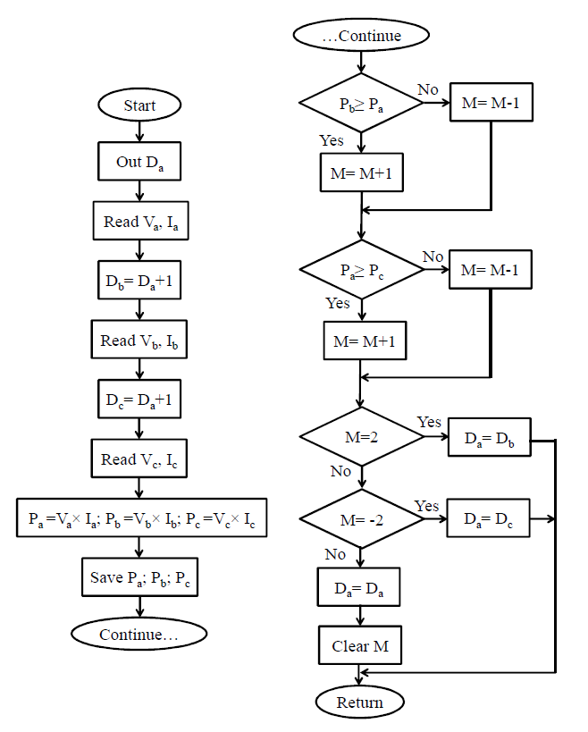

Fig. X - MPPT using three point p&o technique (Source: PEDSTC) [1]

However, another MPPT was preferred by using the improvements of each paper. The biggest weakness of the p&o method is the large steady state error. A question was asked: what if the steady state error can be cancelled?

**How does this MPPT algorithm address the issue?**

While the three point p&o method might nullify the inability of the conventional p&o to respond to drastic changes in the environment, it will not nullify the large steady state error of the conventional p&o. Thus, the proposed improved p&o will detect when the oscillation starts and make the duty cycle output constant. Only if a certain change of power is reached will the circuit reset itself and start tracking the MPP again.

**What are the improvement shown from this MPPT?**

As mentioned above, the major improvement of the constant duty cycle p&o will provide stability to the system while adapting to the environment by resetting and re-initialising the data when a large change in power is detected. It will cancel the steady state error out as well as not losing track of the MPP.

**Any potential issue(s) with this proposed MPPT?**

While it was easy to implement each of the proposed MPPT to improve the p&o method, it will only show a small improvement. Combining several of them might bring incompatibility issues and thus was a tedious task to isolate each method to find the perfect balance. While the constant duty cycle was chosen as the main method, its greatest weakness is the time it is taken to find the MPP before settling. While the settling might be higher than conventional p&o methods, the stability of the system is deeply increased. As the project only asked to improve and find the weaknesses of the p&o, the greater time weakness was preferred to accommodate greater stability.

### **3.1.b. MPPT Algorithm 2 (Temperature)[2]**

**What particular issue of MPPT has this paper addressed?**

The particular issue addressed by this paper is the change of environment in photovoltaic system. Using the constant voltage reference and the perturb & observe method isn’t as flexible as the proposed MPPT. The paper explains how thee temperature algorithm can adapt to the different environment changes while keeping track of the maximum power point of the system.

**What is the algorithm of the proposed MPPT?**

The proposed MPPT is using the temperature of the PV panel to determine and change the position of the maximum power point accordingly. On top of the voltage being fetched, The temperature sensor will sense the amount of heat from the light source and use the voltage and power obtained from it to change the duty cycle to reach the MPP. A flowchart found from the paper is shown below, showing the technical side of the algorithm and how the microcontroller should behave.

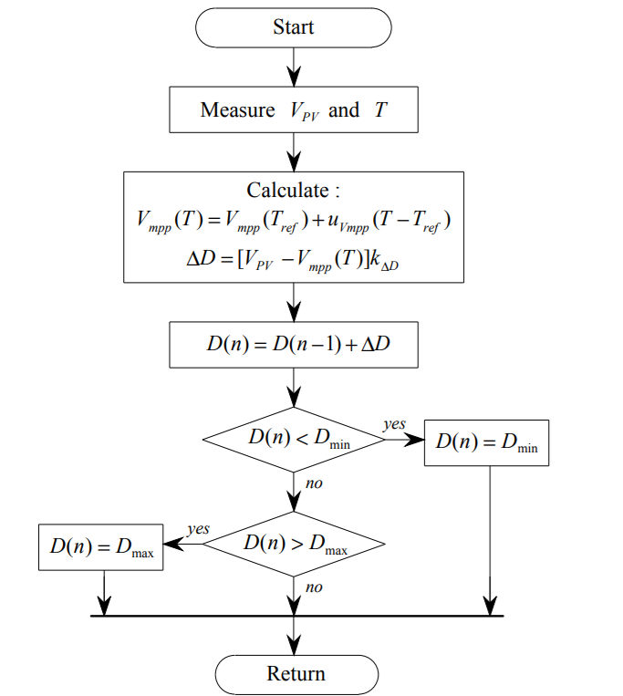

Fig. X - Temperature algorithm flowchart (Source: International Conference on Control, Automation and Systems)

**How does this MPPT algorithm address the issue?**

To overcome the energy efficiency on photovoltaic systems, conventional MPPT methods such as Constant Voltage (CV), Perturbation and Observe (P&O) and Incremental Conductance (IC) are used to optimise the MPPT. These methods, however, have large oscillations in steady state, cannot track the MPPT when conditions are changing rapidly and require very high CPU performance to execute.

By using the optimal voltage and determining the temperature and temperature co-efficient of the PV module, the algorithm used to obtain the MPPT will become a linear equation, which does not require high CPU performance to execute. It will also compare the temperature of the solar module and compare it with the output of the solar cell array’s power output and the MPP is then traced.

This method is advantageous over the Constant Voltage and Incremental Conductance methods as both of these methods are mixed together to obtain the optimal voltage for the MPPT.

**What are the improvement shown from this MPPT?**

Higher and more efficient performance for better readings and results. Since it is flexible to work under stricter and demanding conditions, it is also optimal to implement the temperature method over P&O algorithms for power systems as it will become simpler to solve with only one linear equation, leading to lower CPU performance requirements to compute, can be used with digital and/or analogue circuits, no steady state oscillations and instabilities as temperature varies with time, robust against noise and are typically low costing to implement.

**Any potential issue(s) with this proposed MPPT?**

At lower irradiance levels, estimations are more likely to be impactful on the results as the temperature sensor used might not pick up on the temperature for the PV module. Another weakness of the system is having access to the power curve or calculating it experimentally before the implementation od the algorithm. This disadvantage can be fatal if working under time-constraint. In addition, hard-coded values needs to be implemented in the code, a major weakness inherited from the constant voltage method. Potential deterioration of the efficiency of the PV panel over time might also change the position of the MPP and thus impact the efficiency of the algorithm and the equation used.

### **3.1.c. MPPT Algorithm 3 (Radiation)[3]**

**What particular issue of MPPT has this paper addressed?**

The common problem across all MPPT algorithm is to track the right duty cycle to obtain the maximum power output across all forms of input data such as PV emulator or a PV panel. In Pv panels radiation is always adjusted across time, it is never consistent with its input and always change it input values across time. It is randomised and always hard to detect.

In other cases, it is very difficult to track the MPPT as radiation of the sun change very frequently. This is one of the cases of having issues of tracking MPPT. Radiation is always different from different areas of the world which causes it to be hard to track the MPP.

**What is the algorithm of the proposed MPPT?**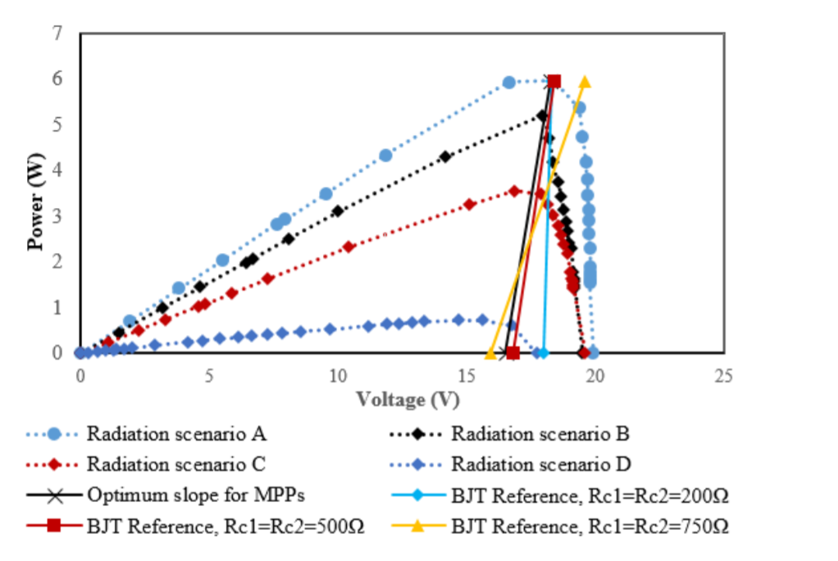

To improve the efficiency of PV systems and improve the MPPT method is by detecting and collecting data from radiation range and values.How this works is by collecting data from maximum radiation to minimum radiation and retrieve the P-V and I-V curve. By doing this, collecting the curves from maximum radiation to minimum radiation a particular area produces can be used to develop an equation where the MPPT will always be positioned.

This will not give 100% accuracy but will give a ∓ 5% offset towards the exact position of the MPPT. To obtain the radiation level a light sensor. UV sensor is used to detect the maximum and minimum amount of radiation produced by a particular area and is recorded down as well as the P-V & I-V curve. An example graph can be shown in figure XX

From implementing the P-V curve, an equation of the line can be produced from the maximum, middle to minimum radiation where the MPPT is located. This is then used as a guideline on where the algorithm can locate the MPPT quickly when exposed to the PV system.

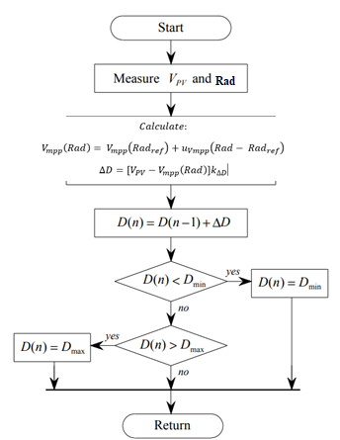

Figx. Flow chart of how the radiation MPPT works.

**How does this MPPT algorithm address the issue?**

This addresses the issue by implementing a radiation reference power curve and using the algorithm to position the duty cycle to the correct MPPT position. This improves the efficiency of the MPPT as it is very quick to detect and position where the MPP is. This uses the equation of Power and voltage to trace the maximum to minimum values.

**What are the improvement shown from this MPPT?**

At steady state, there are no oscillations within the waveform, making the MPPT method easy to track and obtain accurate results. However there are some offset that would not track the correct MPPT and radiation is always different which means that maximum and minimum radiation could be different on some conditions. This improvement only requires the radiation, Power and Voltage to plot where the MPPT reference would be which then the algorithm would track and plot.

**Any potential issue(s) with this proposed MPPT?**

Arduino sensors were not working during the time of testing and could not read what sort of radiation is being emitted. This held back delays as finding a way to fix the sensor did not conclude. Therefore this method was scrapped and moved into improved P&O. There were too many offsets and scenarios where this proposed MPPT would go wrong such as boundaries of radiation could be different. Power and Current could give a different value as compared to the reference graph. Lastly the offset is far too big for tracking to be accurate.

## **3.2. Design of an improved MPPT Algorithm**

### **3.2.a. Statement on the Design Chosen**

The design chosen between the three chosen is the improved P&O. Its ease of implementation and the multitude of reliable sources to support the project. While radiation MPPT has been attempted, no adequate sensors has been found. Our first attempt consisted of using a UV sensor to check the different radiation and calculate the duty cycle from the different irradiances. However, the visible light was out of the range of the sensor and was then replaced by a photoelectric resistor.

Due to time constraint, the improved P&O was selected to complete the project. Two clear techniques to improve the p&o method was proposed. The first method, three point p&o method, enhanced the adaptability of the conventional p&o while the constant duty cycle p&o method brings more stability to the system in terms of steady state error. Both were implemented and tested, and after several debates between team members, the constant duty p&o method has been unanimously chosen.

### **3.2.b. Flow Chart of the Proposed MPPT Algorithm**

As the constant duty p&o method was chosen, its flowchart is shown below.

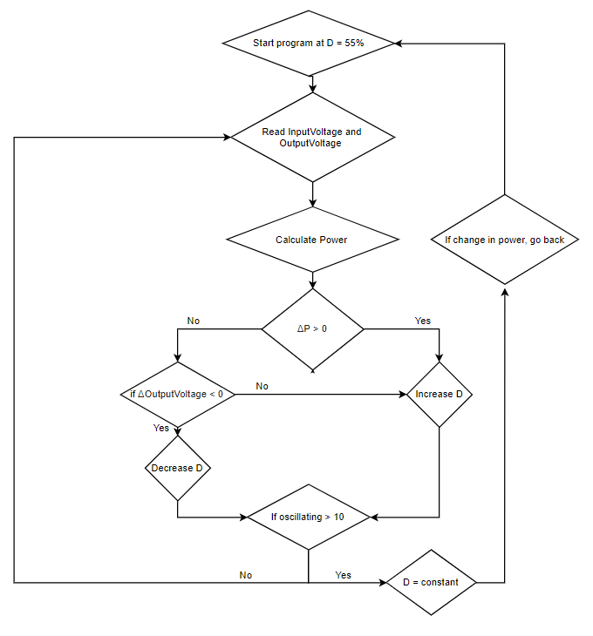

### **3.2.c. Implementation on Arduino**

While the three point p&o has not been chosen, it was still implemented during the project time. The flowchart in the earlier sections explained its functionality and the code below shows how it was implemented.

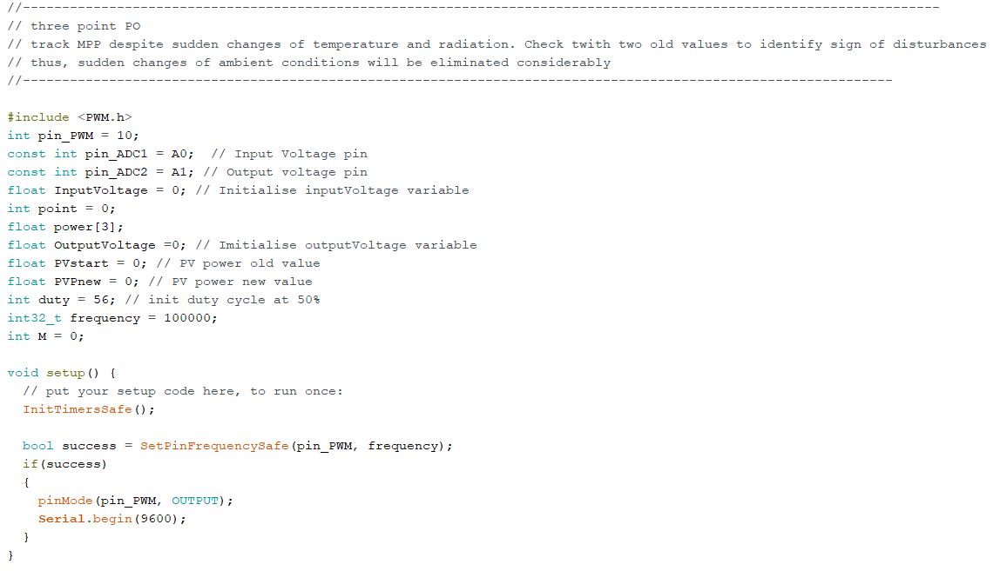

Fig. X - Three point p&o initialisation

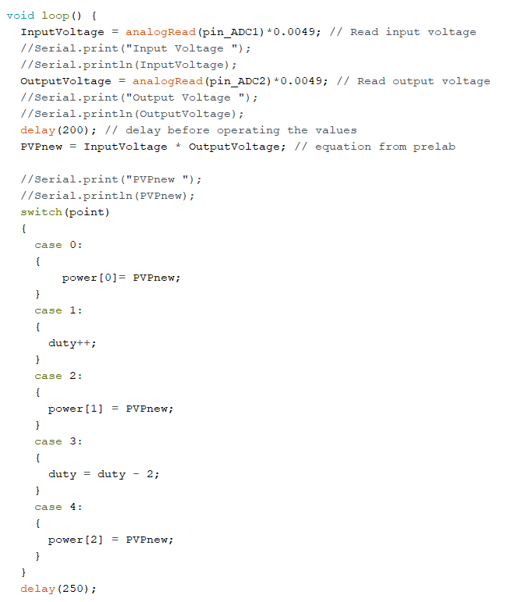

Fig X - Case statement of the three point p&o method

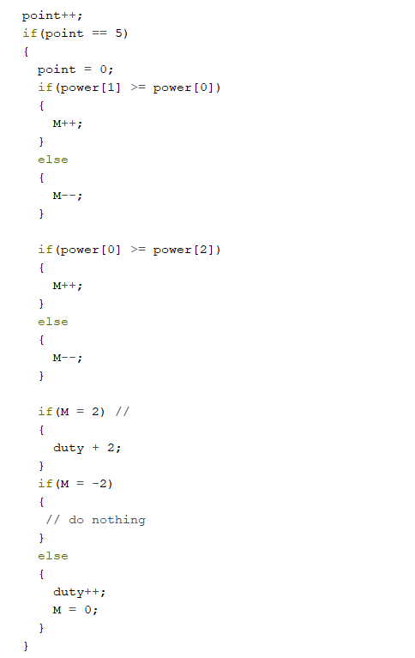

Fig X - variable M conditions

Comparing the three point references, which are the power at duty D, D+1 and D-1, the value of M will vary between -2 and 2. The duty cycle output will change according to the value of M.

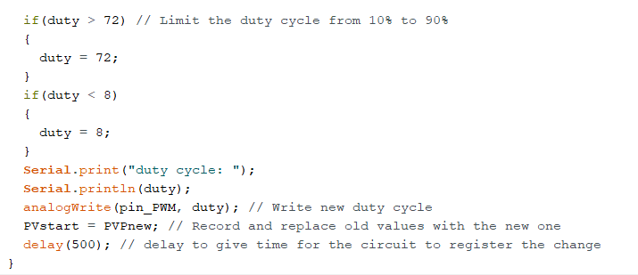

Fig X - Duty cycle limitation and output

Despite its successful implementation, the final design does not incorporate the three point reference p&o and the constant duty cycle p&o method was preferred.

As explained in the flowchart, the goal of the constant duty cycle p&o is to increase the stability of the perturb and observe method. Several other variables are initialized on top of regular p&o method. The last two duty cycles will be recorded as well as the oldInputVoltage, the number of times it will be oscillating and a flag that is raised when the maximum power point is found. The initial duty cycle was chosen to be 55% due to our results from lab 4, ranging the duty cycle from 70% to 90%. However, changing the resistance will vary the duty cycle at which the maximum power point will be sitting.

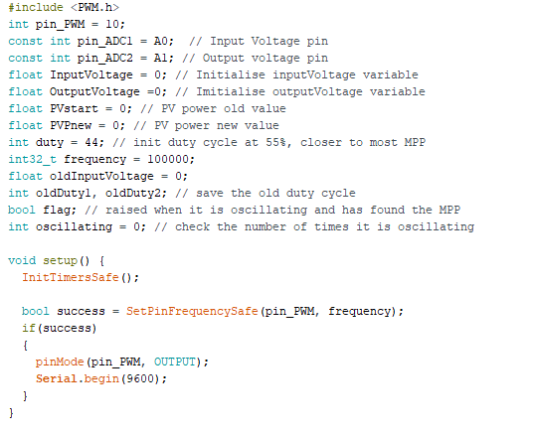

Fig. X - variable initialisation and setup

In the main loop, we read the outputVoltage of the buck converter and the inputVoltage of the PV emulator. After calculating the value of the power (the product of the inputVoltage and the outputVoltage), we increase/decrease the duty cycle accordingly.

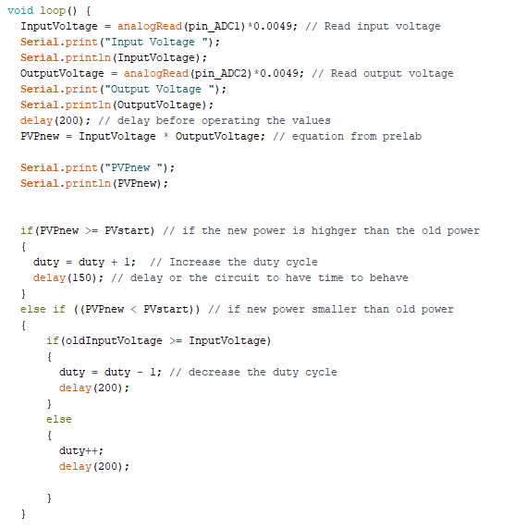

Fig. X - loop and duty cycle variation

After limiting the duty cycle to a range of 10% to 90%, the second last duty cycle is compared with the latest duty cycle. If the code is oscillating between two duty cycles, they should be equal to each other. For example, if the code is oscillating, the following sequence for the duty cycle should be read: 55, 56, 55 , 56, 55, 56… Thus, ww notice that the last duty cycle will always be equal to the second last duty cycle recorded. After finding it oscillating around the same point around the same point for 10 times, the flag is raised in the next if statement, along with making the duty cycle constant.

In the next condition, where the flag should be raised, if the absolute change in power is greater than 0.3, the oscillating state is reset, the flag is dropped, the old values are cleared and the duty cycle resets to 55%.

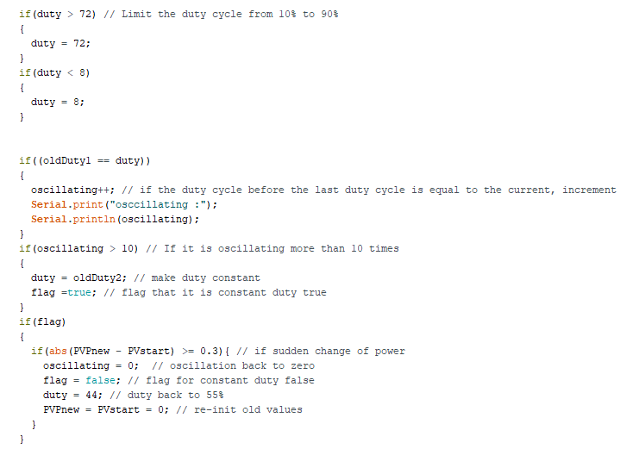

Fig. X - duty cycle limitation and oscillation detection

Finally, the last few lines of the code are saving the old values as a sliding window and writing the new duty cycle to the PWM.

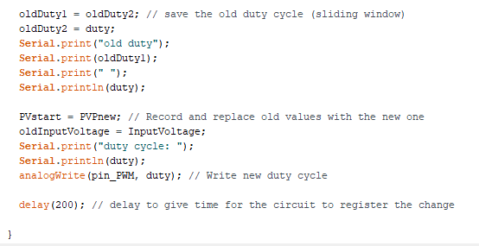

Fig. X - Saving old values and writing new values

### 

# **3.3. Implementation and Testing of the Proposed MPPT Algorithm**

## **3.3.a. Results**

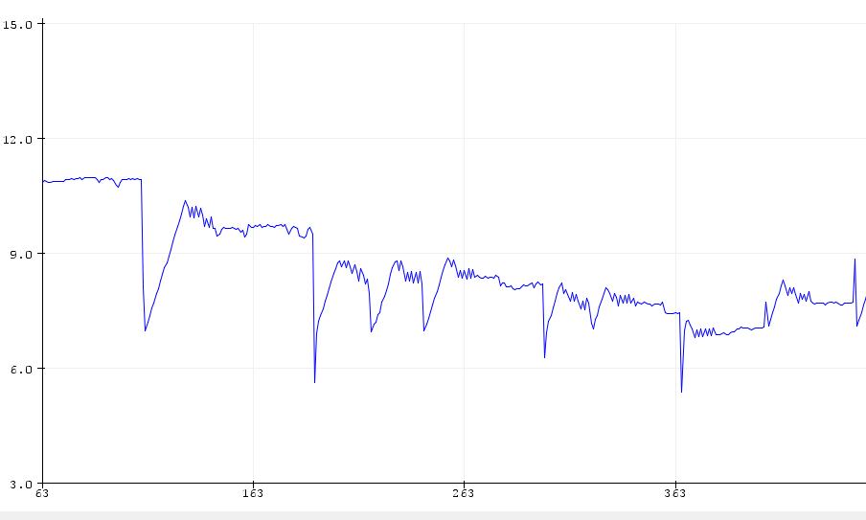

Fig. X - Power step-down from 0.4 A to 0.2 A

In FigureXX, shows a clear coding execution onto the graph. As current decreases the code would reset and return to 50% duty as shown in the dips. This dip occurs to pinpoint and track the mppt over again. The ‘Zig zags’ at the amplitude at each wave demonstrates the “oscillation method”where the code would then track and check the last 2 power to see if it is the same.

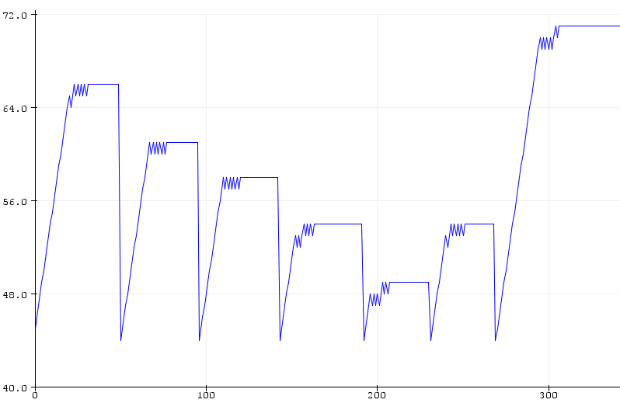

Fig X - Change of duty with 0.05A step down and step up

In figureX, shows a clear demonstration of codes behaviour across duty cycle against the change of current. This graph is obtained by using the arduino serial plotter which displays the Duty cycle against change in current. When the code starts the duty cycle is increased to pinpoint and track the MPPT. This is then goes into “oscillation method”where it detects the lastest duty cycle and previous duty cycle. This is oscillating between two duty cycles and they reach to the constant duty cycle of the MPPT.

For example, if the code is oscillating, the following sequence for the duty cycle should be read: 55, 56, 55 , 56, 55, 56… Thus, ww notice that the last duty cycle will always be equal to the second last duty cycle recorded. After finding it oscillating around the same point around the same point for 10 times, the flag is raised in the next if statement, along with making the duty cycle constant.

**Dso Results**

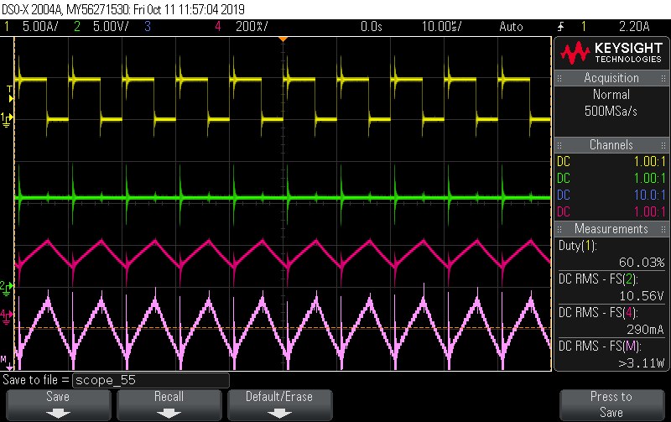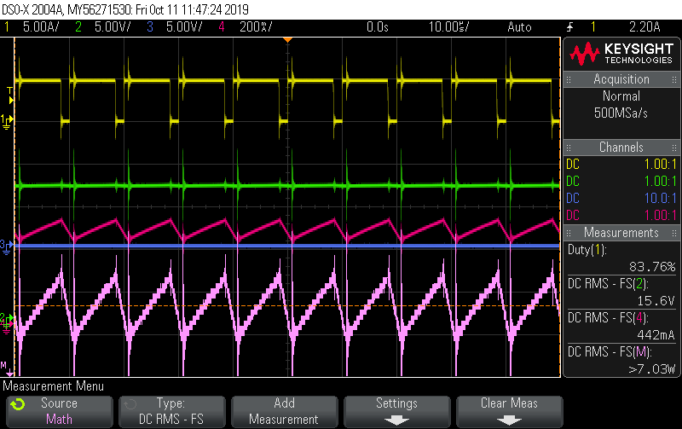

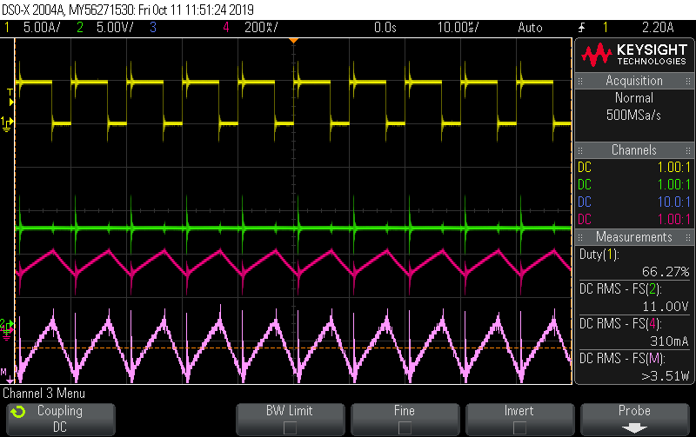

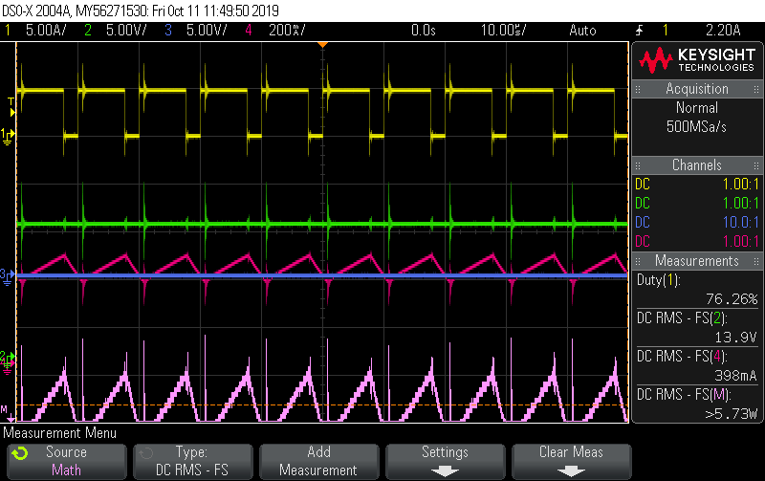

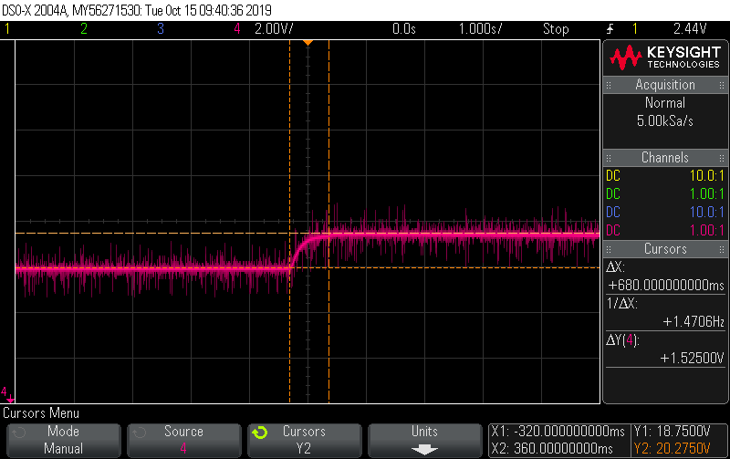

Fig. X - Step down transient response

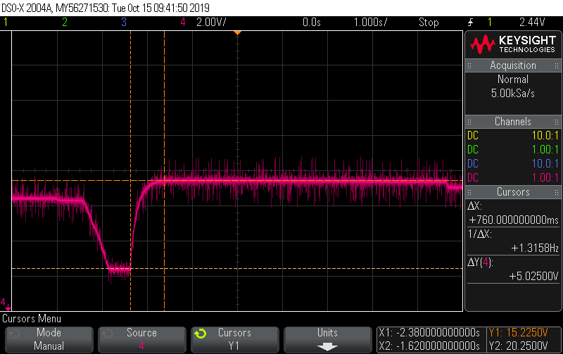

Fig. X - Step up transient response

## **3.4. Conclude Design and Feedback**

In conclusion, the new MPPT chosen has greatly enhanced the p&o method in terms of stability. However, its slow start and resets after a big change of power slowed down the process, which is its weakness. Stability was preferred over speed, and the graph in the results section has proven that the stand we took was right. The next steps to further improve the constant duty cycle p&o method is to increase the speed while increasing the stability. Furthermore, instead of resetting the duty cycle to 55% when the change in power is superior to the threshold, resetting the duty cycle only halfway from 55% will decrease the time taken to find the changed MPP.

Overall, the positive feedback and results has shown us that thinking outside the box has helped us implement a new way to improve the p&o method. In fact, the constant duty cycle was not found in past scholarly articles but designed by the members of this team and their critical thinking.

# **References**

|  |  |
| --- | --- |
| [1] | M. P, B. J and C. S, “Comparison of Perturb & Observe and Hill Climbing,” *Comparison of Perturb & Observe and Hill Climbing,* p. 6, 2019. |
| [2] | M. F. Seyyed, S. S. Milad and T. Amin, “Comparison of Three-Point P&O and Hill Climbing,” *Comparison of Three-Point P&O and Hill Climbing,* p. 5, 2019. |
| [3] | A. E. Imad, P. Yury and K. Moustapha, “Improving Accuracy and Response Time of P&O,” *Improving Accuracy and Response Time of P&O,* no. 8, p. 5, 2018. |
| [4] | S.-G. Xavier, G.-R. Jose and C.-C. Xavier, “Improved Variable Step Size P&O MPPT Algorithm,” *Improved Variable Step Size P&O MPPT Algorithm,* p. 6, 2016. |
| [5] | A. Jubaer and S. Zainal, “An improved perturb and observe (P&O) maximum power point tracking,” *An improved perturb and observe (P&O) maximum power point tracking,* p. 12, 2015. |
| [6] | J. Da-Eun, K. Jae-Sub, L. Jin-Gook and C. Dong-Hwa, “MPPT Control of Photovoltaic System using Optimization Voltage with Temperature,” *MPPT Control of Photovoltaic System using Optimization Voltage with Temperature,* no. [https://ieeexplore-ieee-org.ezproxy.lib.uts.edu.au/stamp/stamp.jsp?tp=&arnumber=6393297], p. 5, 2012. |
| [7] | M. A. Soeidat, D. D.-C. Le and J. Zhu, “An Analog BJT-Tuned MPPT Techniques for PV Systems,” *An Analog BJT-Tuned MPPT Techniques for PV Systems,* p. 5, 2018. |

websites to use

* <https://www.researchgate.net/publication/304414944_Comparative_analysis_of_PO_modified_hill_climbing-FLC_and_adaptive_PO-FLC_MPPTs_for_microgrid_standalone_PV_system>
* <https://www.researchgate.net/publication/305830025_Photovoltaic_maximum_power_point_tracking_under_fast_varying_of_solar_radiation>
* <https://www.jaycar.com.au/medias/sys_master/images/9292285247518/XC4518-dataSheetMain.pdf>